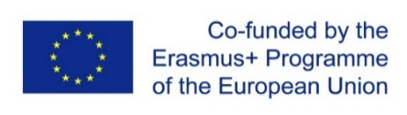

MEMORANDUM OF UNDERSTANDING
WITHIN THE FRAMEWORK OF PROJECT REALIZATION 585596-EPP-1-2017-1-DE-EPPKA2-CBHE-JP
Fostering Internationalisation in AgRicultural Engineering in Iran and Russia/FARMER
between
Volgograd State Technical University (VSTU)
and

§ 1
The following MOU based on a mutual interest and an active dialoguewhile joint work on project 585596-EPP-1-2017-1-DE-EPPKA2-CBHE-JP Fostering Internationalisation in AgRicultural Engineering in Iran and Russia/FARMER and will be the basis for a long-standing and trustful cooperation of the two universities for the purpose of setting a double degree program in agricultural engineering. Specific details of any activity between the universities shall be set forth in a bilateral Supplemental Letter of Agreement.If both universities manifest their further interest, this MoU can result in a separate cooperation contract between the universities.

§ 2
The objectives of this MOU shall include, but not be limited to the following:
1. the organization of double degree program in agricultural engineering or others,
2. the exchange of academic staff for lectures, conferences and research,
3. the exchange of students for courses and double degree programs, and
4. the exchange of publications and other materials of common interest.

§ 3
The cooperating partners shall apply to the national governments or other suitable institutions for funding to support their collaborative activities.

§ 4
Both universities nominate a representative for the further negotiations.
At VSTU the coordinator is Grigory Boyko (boyko@vstu.ru)
At _____ the coordinator is __________ (____________)

§ 5
This MOU shall become effective on the date that it is signed by the representatives of both universities. However it does not constitute legal responsibilities or obligations.

Date: Date:

For and behalf of VSTU For and behalf of
the legal representative the legal representative
Rector Rector
Alexander Navrotskiy _______________

___________________________ _________________________

